Project Report

on

**Automatic Railway Gate Controller with High Speed Alerting System**

**Submitted by**

Sk. Md. Zubayer-Al-Mahmud

**Student ID:** 1017311014

**Course Name:** Embedded System Design

**Course Code:** 5307

**Institute of Information & Communication Technology**

**Bangladesh University of Engineering & Communication Technology**

**(IICT, BUET)**

**Introduction:** The main aim of this project is to operate and control the unmanned railway gate in the proper manner in order to avoid the accidents in the unmanned railway crossing. In a country like ours where there are many unmanned railway crossings, accidents are increasing day by day. These train accidents are due to the absence of human power in the railway. In order to overcome the accidents due to the above problem we have planned to design the project.Automatic Railway Gate Control System with High Speed Alerting System is an innovative circuit which automatically controls the operation of railway gates detecting the arrival and departure of trains at the gate. It has detectors at the far away distance on the railway track which allows us to know the arrival and departure of the train. These detectors are given to microcontroller which activates the motors which open/close the railway gate correspondingly.

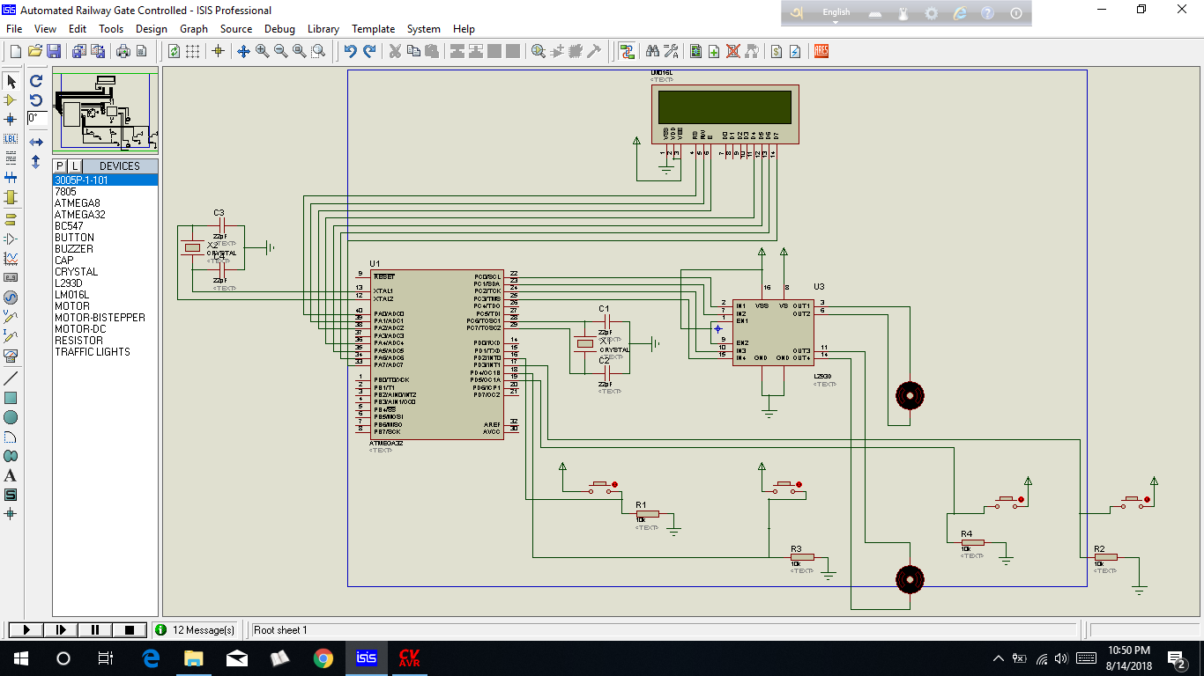

Picture 1: Design of the project in Proteus

**Required Components:**

1. DC Geared Motors

2. pressure sensor - 4

3. ATmega32 - 1

4. crystal – 2/1

5.IC-L293D - 1

6. Registers

7.Capacitors

8. Battery

9. LCD display

10. some wires, burg strips etc.

**Flow chart of the program developed :**

Input sensor

Train Arrive????

Gate open

Train Departure

Speed calculation

Gate close

**Program code :**

#include <mega32.h>

#include <alcd.h>

#include <delay.h>

#include <stdlib.h>

#define push1 PIND.2

#define push2 PIND.3

#define push3 PIND.4

#define push4 PIND.5

#define buzz_ddr DDRB

#define buzz PORTB

// Declare your global variables here

float speed=0;

char disp[16];

int second=0, time=0;

int distance=10; // distance= 10 meter

// Timer1 overflow interrupt service routine

interrupt [TIM1_OVF] void timer1_ovf_isr(void)

{

TCNT1H=0xC2;

TCNT1L=0xF7;

second++;

if(second==2){

PORTC = 0b00000000;

} }

void main(void)

{ buzz_ddr=0xFF;

TCCR1A=(0<<COM1A1) | (0<<COM1A0) | (0<<COM1B1) | (0<<COM1B0) | (0<<WGM11) | (0<<WGM10);

TCCR1B=(0<<ICNC1) | (0<<ICES1) | (0<<WGM13) | (0<<WGM12) | (1<<CS12) | (0<<CS11) | (1<<CS10);

TCNT1H=0xC2;

TCNT1L=0xF7;

ICR1H=0x00;

ICR1L=0x00;

OCR1AH=0x00;

OCR1AL=0x00;

OCR1BH=0x00;

OCR1BL=0x00;

// Timer(s)/Counter(s) Interrupt(s) initialization

TIMSK=(0<<OCIE2) | (0<<TOIE2) | (0<<TICIE1) | (0<<OCIE1A) | (0<<OCIE1B) | (1<<TOIE1) | (0<<OCIE0) | (0<<TOIE0);

lcd_init(16);

lcd_gotoxy(0,0);

DDRC=0xFF;

DDRD=0x00;

// Global enable interrupts

#asm("sei")

while (1)

{

if(push1==1)

{

while (1)

{

if(push1==1){

lcd_clear();

lcd_gotoxy(0,0);

lcd_putsf("Train Comming");

lcd_gotoxy(0,1);

lcd_putsf("Gate Close");

delay_ms(10);

//clockwise rotation

PORTC = 0b00000101;

second=0;

buzz = 0xFF;

}

if(push3==1){

lcd_clear();

lcd_gotoxy(0,0);

lcd_putsf("Train speed:");

delay_ms(5);

lcd_gotoxy(0,1);

time=second;

second=0;

delay_ms(500);

speed=distance*3.6; //speed= km/hr

speed=speed/time;

ftoa(speed,2,disp);

lcd_puts(disp);

delay_ms(5);

lcd_gotoxy(8,1);

lcd_putsf("km/hr");

delay_ms(10);

second=0;

}

if(push2==1){

buzz = 0x00;

lcd_clear();

lcd_gotoxy(0,0);

lcd_putsf("Train departure");

lcd_gotoxy(0,1);

lcd_putsf("Gate Open");

// counter-clockwise rotation

PORTC = 0b00001010;

delay_ms(2000); // wait 2s

PORTC = 0b00000000;

break;

} } }

////////////////////////////////////////////////////////

if(push2==1)

{

while (1)

{

if(push2==1){

lcd_clear();

lcd_gotoxy(0,0);

lcd_putsf("Train Comming");

lcd_gotoxy(0,1);

lcd_putsf("Gate Close");

delay_ms(10);

//clockwise rotation

PORTC = 0b00000101;

second=0;

//delay_ms(2000); // wait 2s

buzz = 0xFF;

}

if(push4==1){

lcd_clear();

lcd_gotoxy(0,0);

lcd_putsf("Train speed:");

delay_ms(5);

lcd_gotoxy(0,1);

time=second;

second=0;

delay_ms(500);

speed=distance*3.6/time; //speed= km/hr

//speed=speed/time;

ftoa(speed,2,disp);

lcd_puts(disp);

delay_ms(5);

lcd_gotoxy(8,1);

lcd_putsf("km/hr");

delay_ms(10);

second=0;

}

if(push1==1){

buzz = 0x00;

lcd_clear();

lcd_gotoxy(0,0);

lcd_putsf("Train departure");

lcd_gotoxy(0,1);

lcd_putsf("Gate Open");

// counter-clockwise rotation

PORTC = 0b00001010;

delay_ms(2000); // wait 2s

PORTC = 0b00000000;

break;

} } }

} }

**Output of the project in Proteus:**

1st pressure sensor detect by pressing 1st button:

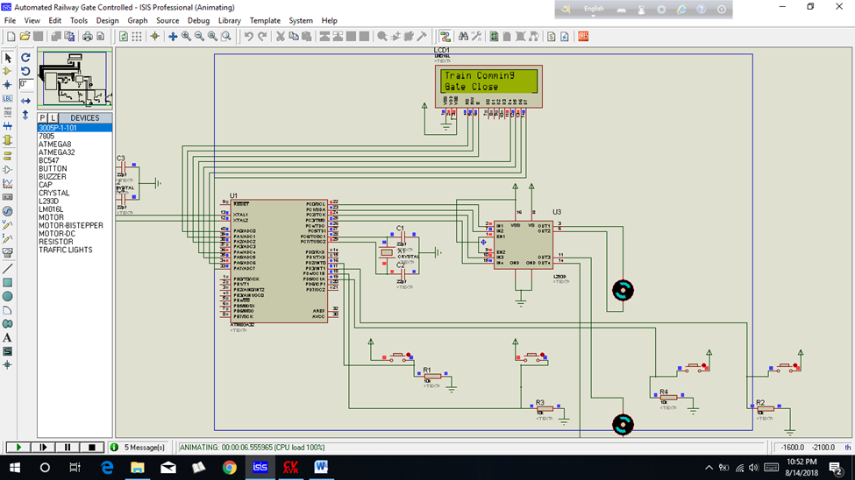

2st pressure sensor detect to speed calculation by pressing 2st button:

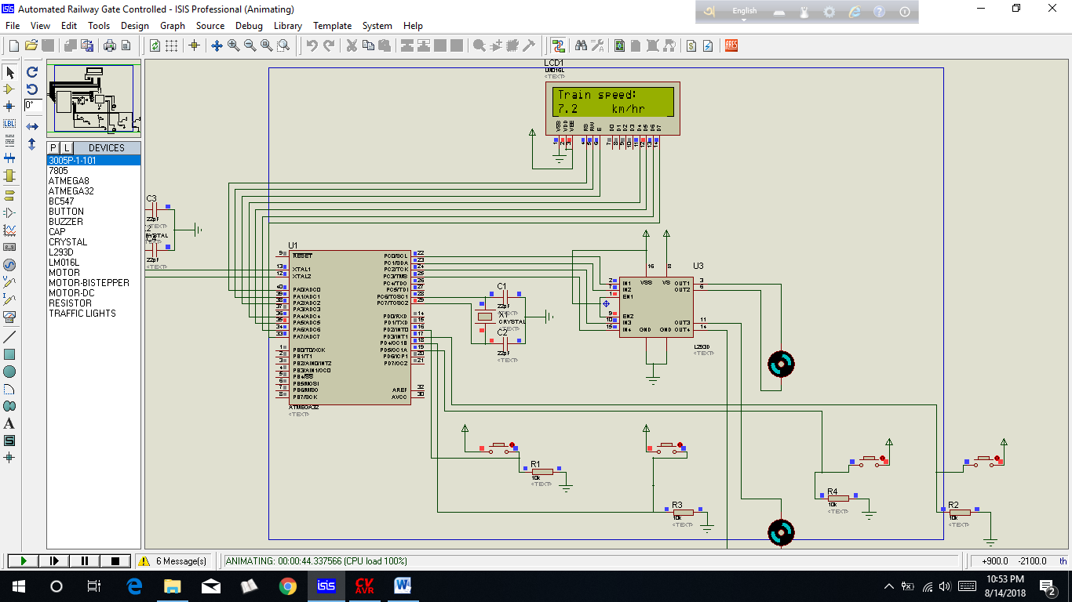

last pressure sensor detect to gate open by pressing last button:

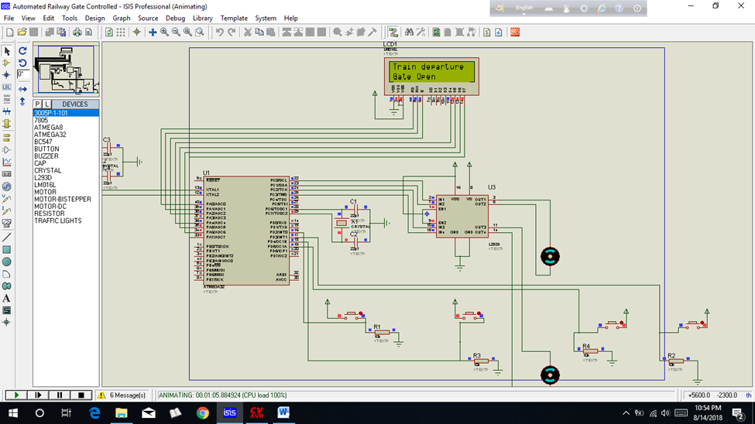

**Advantages and Applications:**

* An Automatic Railway Gate Control is implemented with very simple hardware and easy control.
* Human intervention at level crossings can be removed with the help of this project and many railway level crossing accidents can be prevented.

**Limitations:**

* The system can be implemented more efficiently by incorporating more efficient sensor network.
* A combination manual wireless control and sensors based control can be used for better operation.

**Scope of Future works :**

This project can be more developed in future.

**Conclusion:** Automatic gate control system offer an effective way to reduce the occurrence of railway accidents. This system can contribute a lot of benefit either to the road users or to the railway management. Since the design is completely automated it can be used in remote villages where no station master or line man is present. Railway sensors are placed at two sides of gate. It is used to sense the arrival and departure of the train. This system uses the DC motor to open and close the gates automatically when it is rotated clockwise or anticlockwise direction. The LCD display shows the speed of The train. In this system, this is controlled by using ATmega32 microcontroller. Now a day’s automatic system occupies each and every sector of applications as it is reliable and accurate.